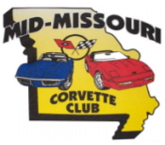
MID-MISSOURI CORVETTE CLUB
Annual Corvette Cup

APRIL 13, 2024

Elk’s Lodge – 4747 E. Elk Park Dr. - Columbia, MO

Pre-Registration of $35 includes: (1) Event T-Shirt.

Registration after April 1st. is $40.
Event t-shirts cannot be guaranteed after April 1st..

8 a.m. to 11:00 a.m. Registration 11:00 a.m. to 2:00 p.m. Car Judging
9 a.m. to 2 p.m. Silent Auction/Vendors 3:00 p.m. Awards

Hotels in the area: Dury Plaza 888-801-1519
Staybridge Suites 573-442-8600
Quality Inn 855-516-1090

Participant Name
Spouse/Guest Name
Address
City State Zip
Phone Email
Corvette Year Color Coupe / Convertible / GS /Z06 / ZR1
☐ $35 Pre-Registration
T-Shirt Size
☐ $15 Extra T-Shirt
Size
☐ $40 Registration after April 1st
License Club Affiliation
Mail Registration To:
Don Martin
2207 Oak Cliff Drive
Columbia, MO 65203
Make checks payable to: Mid-Missouri Corvette Club

REGISTER ONLINE:
WWW.MIDMOCORVETTE.WEEBLY.COM
Email: midmocorvetteclub@yahoo.com

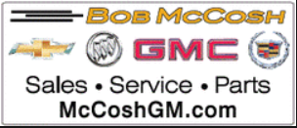

Silent Auction proceeds go to the Central Missouri Dream Factory to grant wishes to critically & chronically ill children.

